Project Proposal: Coworking Space Management System

1. Project Title
FlexSpace: An Integrated Coworking and Workspace Resource Management System

2. Problem Statement
As the demand for flexible work environments increases, managing the allocation of desks, private offices, and meeting rooms manually becomes prone to errors, such as double-booking or inconsistent pricing. Currently, there is a need for a centralized system that tracks member details, workspace availability, and booking schedules to ensure data integrity and operational efficiency. FlexSpace addresses this by providing a digital interface to manage relational data between members and their specific resource reservations.

3. List of Users
- System Administrator: Responsible for managing workspace inventory, setting prices, and overseeing all member bookings.
- Front Desk Staff: Handles the daily check-ins, creates new member records, and processes booking updates or cancellations.
ERD
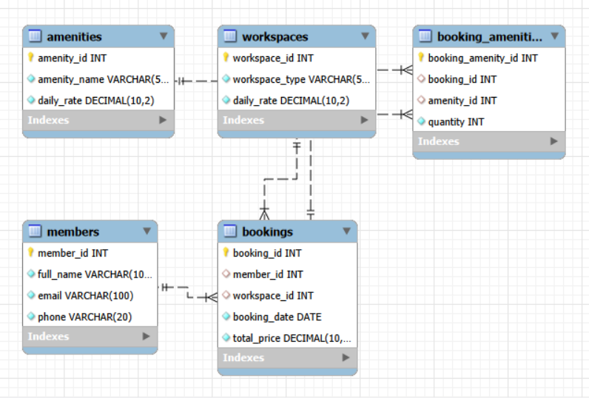

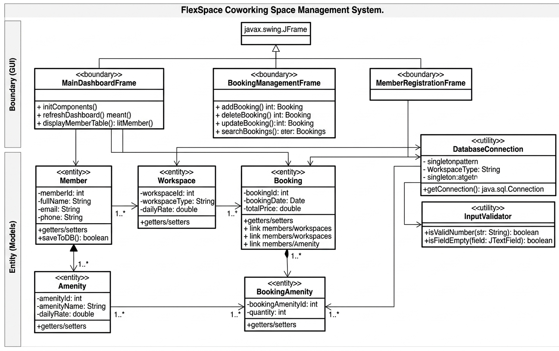
Class Design / UML-style Diagram

Screenshots of GUI
